**Fred A. Olds Elementary School**

**Kindergarten Supply List for the 2016-2017 School Year**

**Student Classroom Supplies**

* Change of clothes (Please label your child’s clothes and place them in a Ziploc bag. The clothes bag should remain in your child’s backpack.)
* Backpack (No rolling backpacks are permitted.)
* Rest **TOWEL** no larger than a beach towel and labeled with your child’s name. **No Mats.**
* (3) Primary composition notebooks (**blank space for pic at top and dashed handwriting lines at the bottom**)
* (3- 1 of each color) **thick plastic** 2-pocket folders with prongs (solid red, solid purple, and solid yellow)
* Package of glue sticks
* (2) packs of CRAYOLA crayons (NO special edition packages ie. princess, pirate, glitter etc)
* Clear zippered pouch (like a pencil pouch for 3 ring binder)
* Package of EXPO fine tip dry erase markers
* Package of EXPO chisel tip dry erase markers
* Box of Kleenex
* Clorox Wipes
* Pack of clear plastic sheet protectors
* Over the ear headphones
* 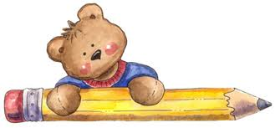(1) Child scissors
* Construction paper
* White copy paper (2 reams)
* (2) packages of regular pencils
* (2) packages of pink rectangular erasers
* (1) package of white 3x5 index cards
* (2) reams of colored copy paper
* (2) reams of white cardstock

**\*PLEASE ONLY LABEL THE CHANGE OF CLOTHES AND REST TOWEL.\***

**We will label all other supplies as needed. Thank you.**